Gun Review: CZ P-10S Optics-Ready 9mm Pistol
By
TTAG Contributor
-
January 6, 2020
27

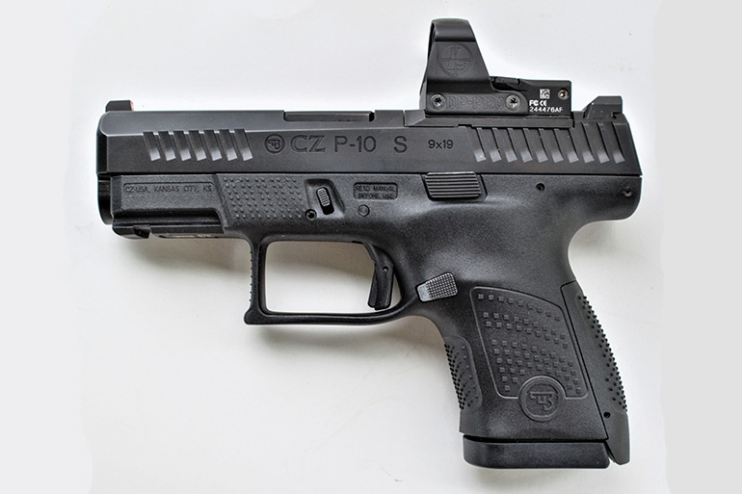

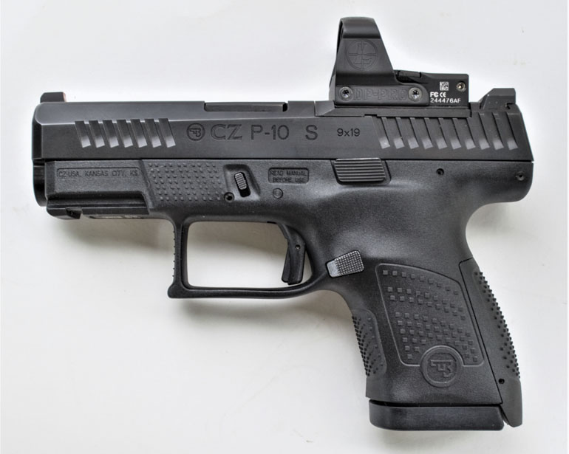
CZ got into the 9mm polymer striker-fired pistol game with the the introduction of the excellent CZ P-10 C. The original pistol was the compact version of the then-new platform. CZ later released the F and S model P-10 pistols.
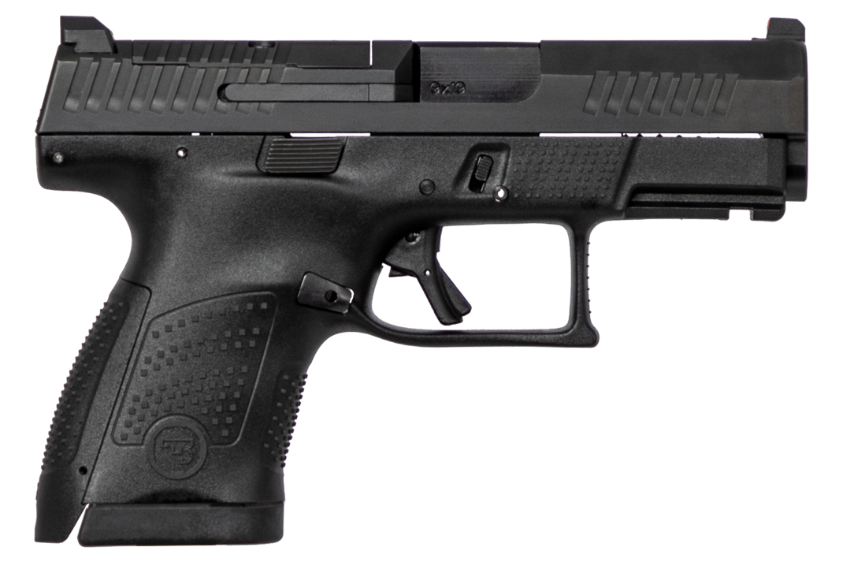
CZ P-10 Optics-Ready 9mm Luger handgun (Courtesy CZ)
Not surprisingly, the F is the full-size pistol, similar to the GLOCK 17. The P-10 S is a sub-compact and fits the same market niche as the G26 and similar pistols.
The P-10 S is slightly larger than the GLOCK 26, but carries two more rounds. While the P-10 guns are similar in general operation to other polymer frame handguns, it’s clearly a pistol with a CZ style that sets it apart.
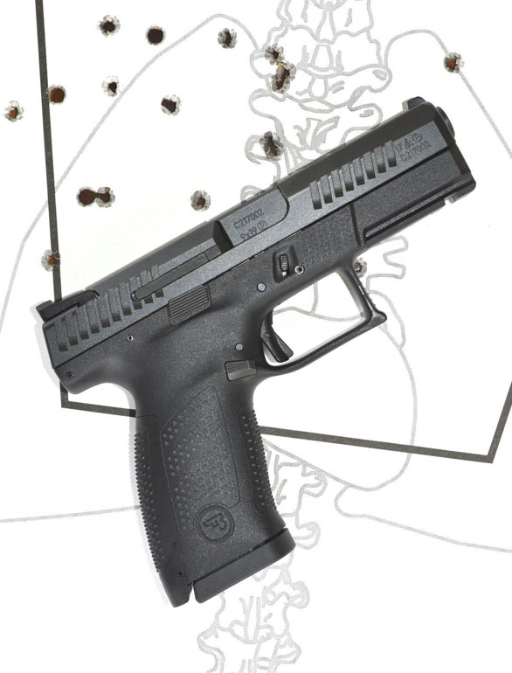
The P-10 S builds off of the excellent ergonomics of the P-10 C (Virgil Caldwell for TTAG)

Features
The P-10 S builds on the P-10 C’s best features, with improvements as a result of shooter feedback. The trigger feels crisper in operation than the original. CZ has also improved the pistol’s magazine release. It’s less stiff now and easily swappable for lefties.
The trigger breaks at a very clean 4 pounds and 10 ounces without creep or backlash. Reset is rapid at about .25 inch travel. A rapid reset is often more beneficial than a light trigger in rapid combat shooting. The CZ-P 10 S trigger is better than most any pistol I have handled in the striker fired category.
The P-10 S’s main advantage over other similar handguns is primarily related to its excellent ergonomics. The grip angle is ideal for most shooters and hand sizes That allows for controlling recoil and getting the pistol on target as quickly as possible.
A slightly undercut trigger guard helps. The pebbled and checkered grip surfaces offer a good balance of adhesion and abrasion.
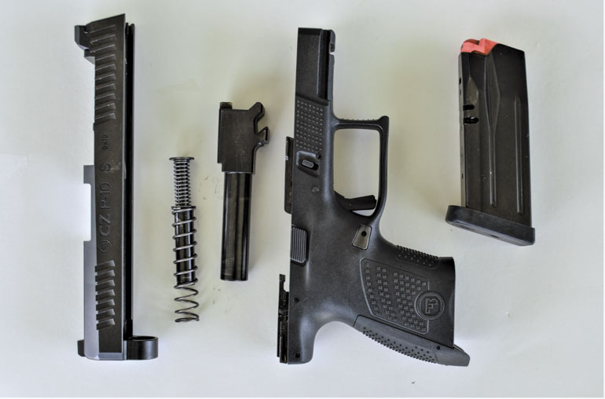
The pistol is supplied with interchangeable backstraps and two 12-round magazines. It will also accept the 15-round magazines designed for the P-10 C.
The P-10 S features forward cocking serrations, has a standard GLOCK-type takedown, good sights and provides excellent reliability.
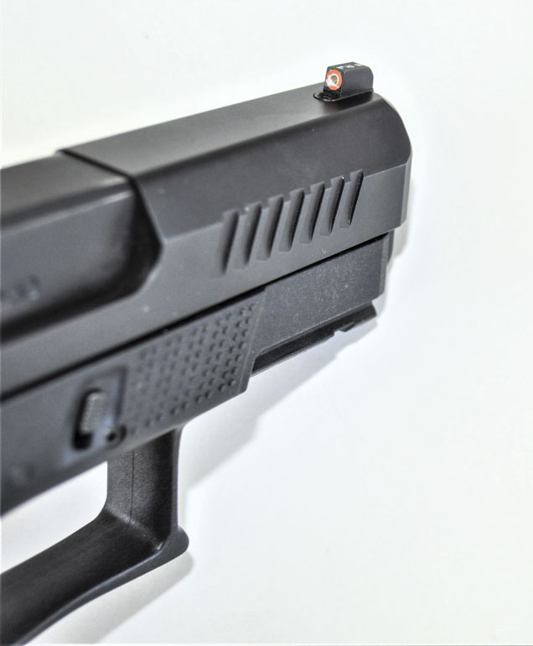
The P-10 S features a bright tritium insert in the front sight surrounded by dayglo orange. The serrated rear sight reminds me of the famous Heinie design.

The P-10 S Optics-Ready
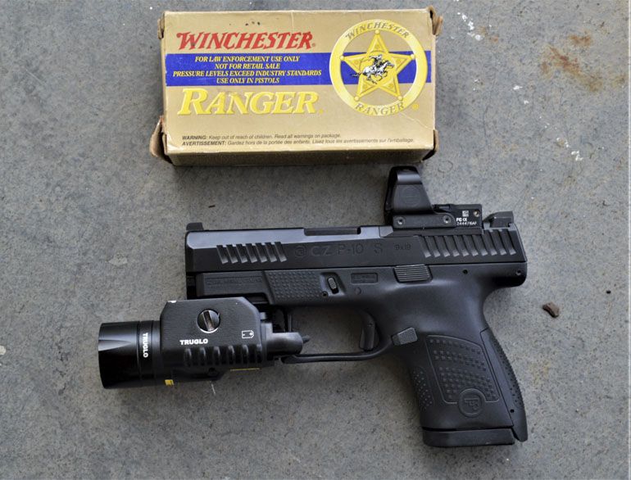
The US-made P-10 S Optics-Ready model is delivered with a blank filler plate. Two versions of plates are currently offered, one for the Trijicon RMR and one for the Luepold Delta Point.
My version didn’t allow co witnessing the sights, but you can order taller sights.
I tested the CZ P-10 S Optics-Ready with a Leupold Delta Point red dot which mounted easily with its plate and made for an easy-pointing, quick-shooting combination.

Testing
The primary load used for most of the range work was standard Winchester white box 115 grain FMJ. I also fired a number of personal defense loads including the Winchester 124 grain PDX +P and Black Hills Honey Badger 125 grain loads.
Accuracy was very good with these loads. I settled down, bracing off of a barricade to test accuracy with the Delta Point mounted. I carefully pressed the trigger five times, keeping the red dot aimed at the center of a man-sized target at 20 yards. The five shots settled in a tight 2.0-inch pattern.
The CZ P10 S Optics-Ready is surprisingly easy to shoot and shoot well. There were no break-in period hiccups, no malfunctions of any type during hundreds of rounds of testing.
Felt recoil was very modest. A combination of a well-shaped grip, good textured surface, a crisp trigger and a well-designed recoil spring result in a pistol that is easy to fire and handle despite its relatively small size and light weight.
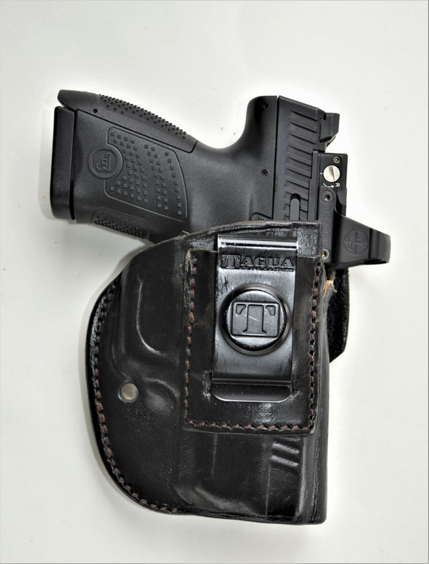
I sacrificed a few leather holsters I already owned by cutting them to accommodate the red dot-equipped CZ P10 S Optics-Ready. I was then able to execute several rapid presentations from concealed carry. The CZ P 10 is a fast handgun to draw and get on target. The pistol offers a good natural point of aim.
The handle fits my average-size hand very well. The P-10 S’s trigger is smooth and after the shot breaks, reset is rapid. With an optic mounted, placing the red dot on the target and pressing the trigger results in a hit. Firing when moving and firing at targets from 7 to 25 yards yielded excellent results.
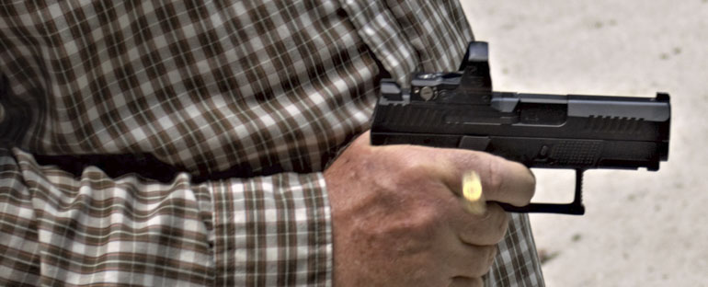
The P-10 S is an ideal size pistol for concealed carry. The P-10 S Optics-Ready is more than accurate enough for any intended use, either with or without a red dot mounted. Reliable, fast-handling and accurate, the CZ P-10 S is a great option for concealed carry, personal and home defence.
Specifications: CZ P-10 S Optics-Ready
Caliber: 9mm
Capacity: 12 + 1 (supplied with two)
Barrel length: 3.5 inches
Overall length: 6.6 in.
Width: 1.26 in.
Weight: 24.4 oz.
MSRP: $577 (about $520 retail)
Ratings (out of five stars):
Style and Appearance * * * *
While polymer striker-fired guns aren’t beautiful, the P-10 S is more attractive than most.
Ergonomics * * * * *
This is a very well designed, easy-handling pistol.
Accuracy * * * *
The sub-compact CZ P-10 S is more than accurate enough for concealed carry and personal defense use.
Overall * * * * 1/2
When capacity, accuracy, reliability, sights and trigger are added up and combined with the pistol’s optics-ready capability, the CZ P-10 S is a very attractive handgun and one of the best 9mm sub-compacts on the market.

